SUSTAINABLE OUTREACH AND UNIVERSAL LEADERSHIP LIMITED
(SOUL)



HUMAN RESOURCE MANAGEMENT

GAP ANALYSIS DOCUMENT

1.Master Data / Screens
  - Employee:

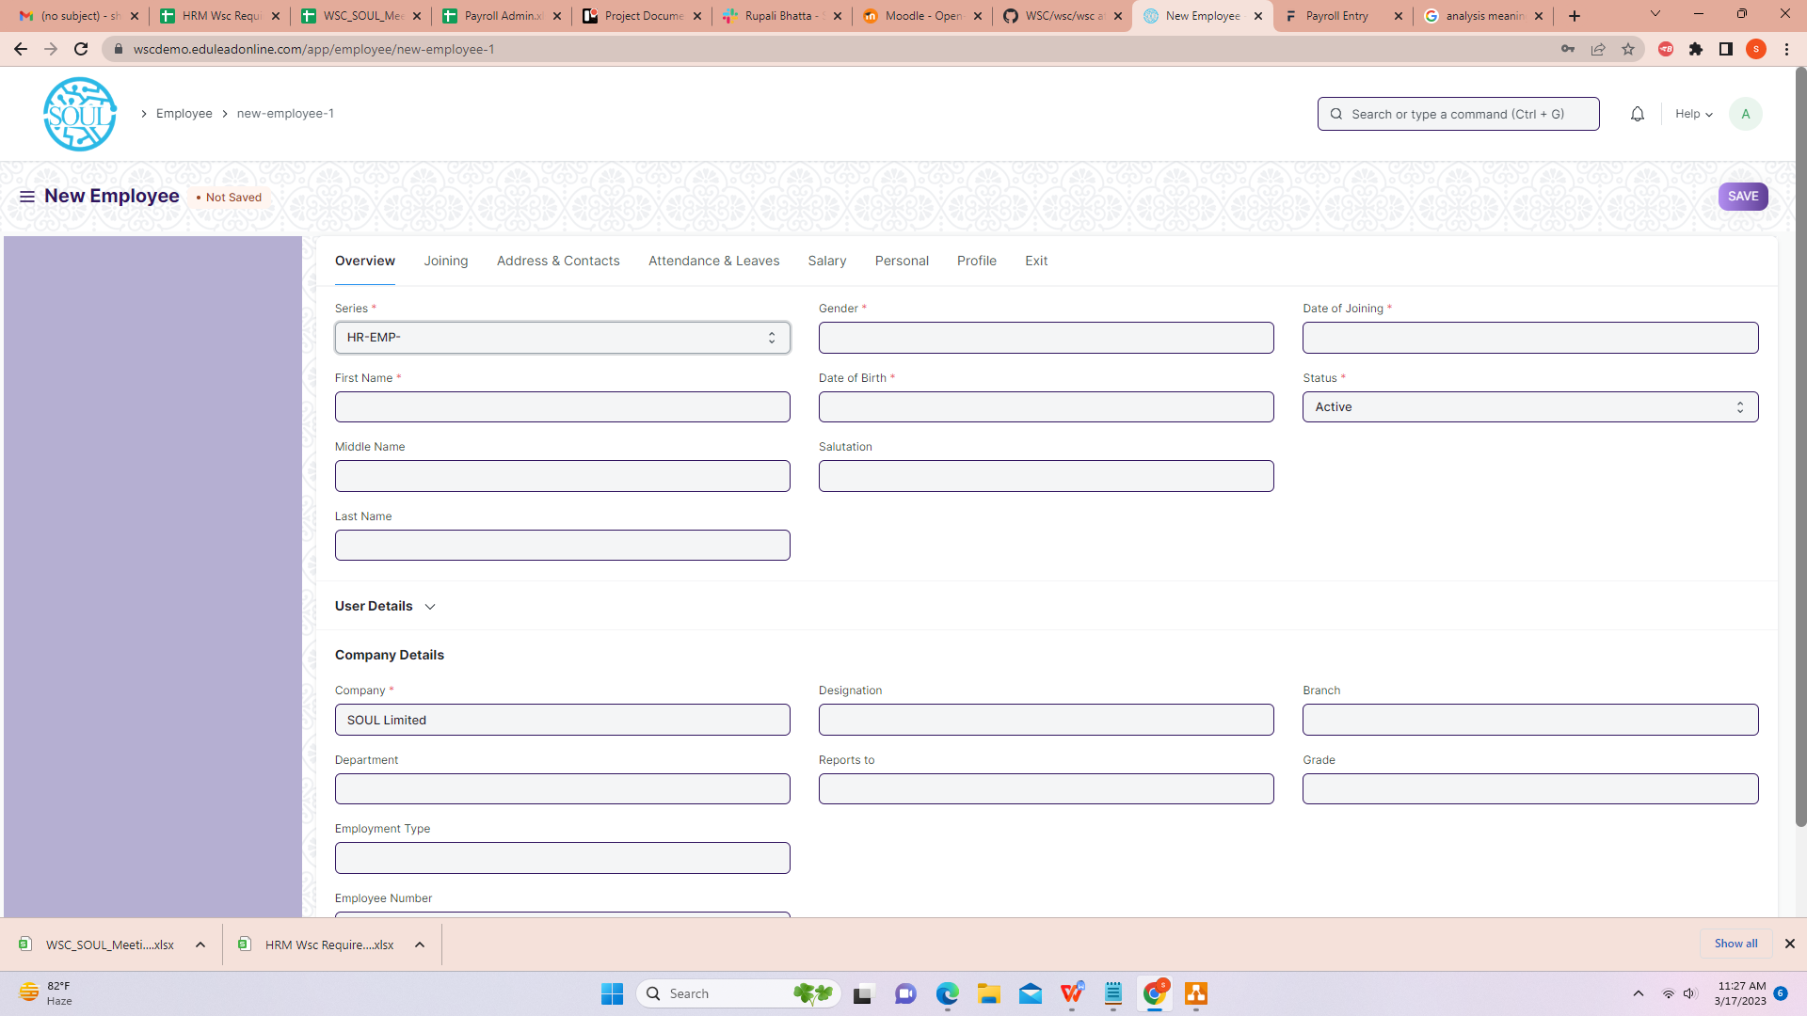

Business Requirement:
- Multiple Department/Designation allotted to an employee should be present in the Employee Screen under “Company Details”.

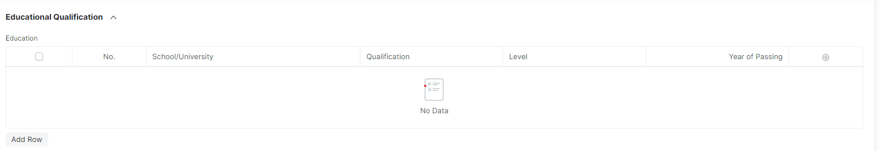

- In the Employee screen,the “educational qualifications” should be fetched directly from the “job applicant”.

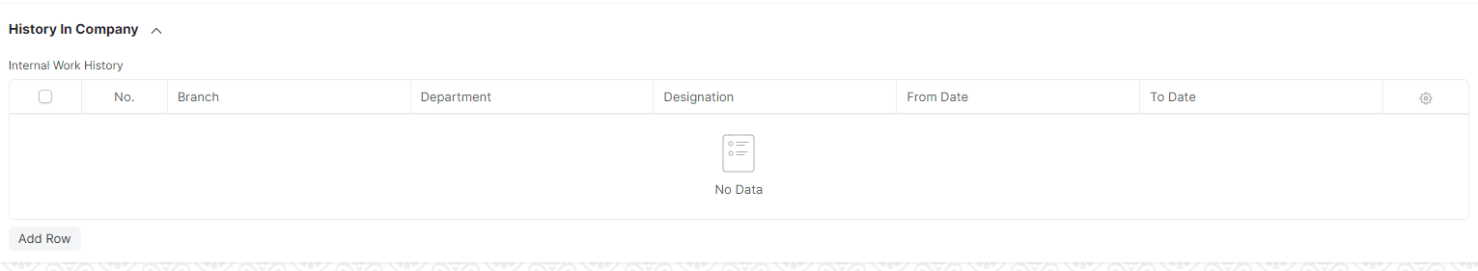

- In the Employee screen,in “History In Company”the employee promotion and employee transfer hierarchy should be maintained(along with multiple department or designation allotted).

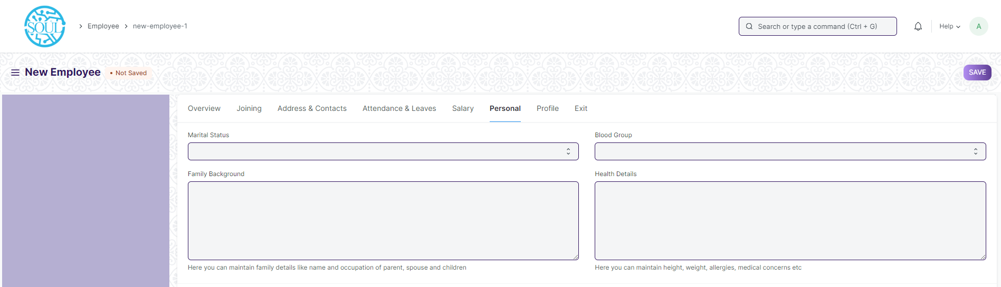

- In “Family Background Details” following fields need to be added:
- Father’s name
- Mother’s name
- Spouse name
- Occupation details of Father,Mother and Spouse
- Annual Income( Father,Mother and Spouse)
- Address and Contact details.
- Health Details like Height,Weight,medical concern for every family members(Father,Mother and Spouse).

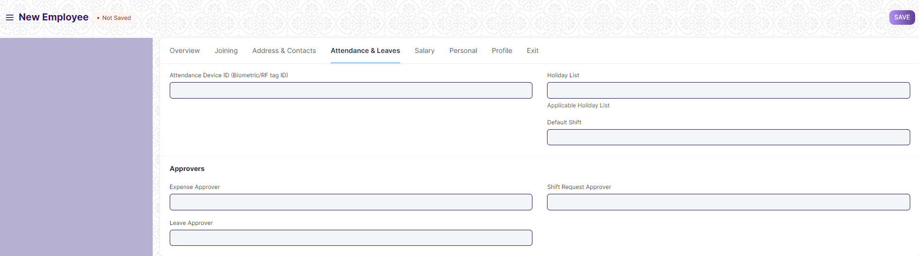

- In “Approver”,there should be two level of Approver
- Recommending Authority and
- Approving Authority for Expenses,Shift Request and Leaves.

- Based on the amount of expenses there should be different level of Approvers.

- “Health Insurance Details” should consists of fields like:
- Health Insurance name
- Health Insurance Number
- Company Name

- “Notice Period ” details like No. Of Days,Status(Served/Not Served) should be present.

2.Recruitment
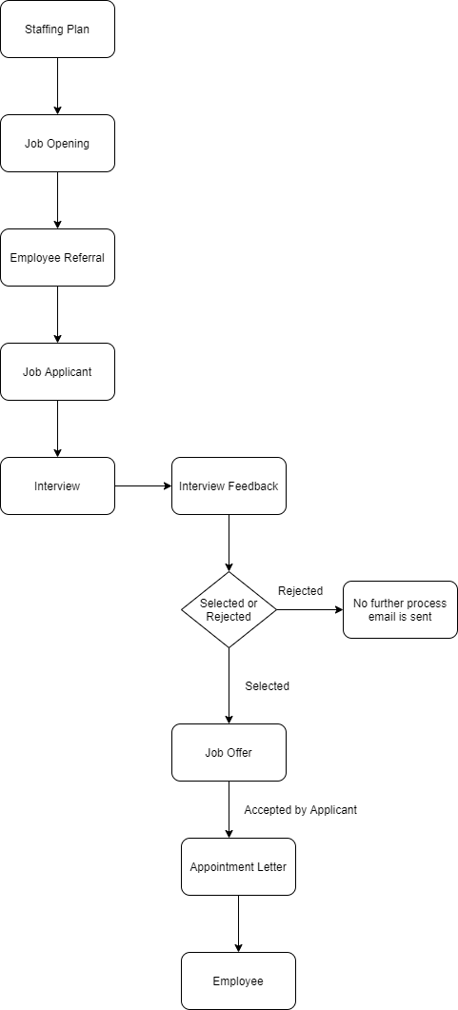

Fig:Existing Recruitment Process

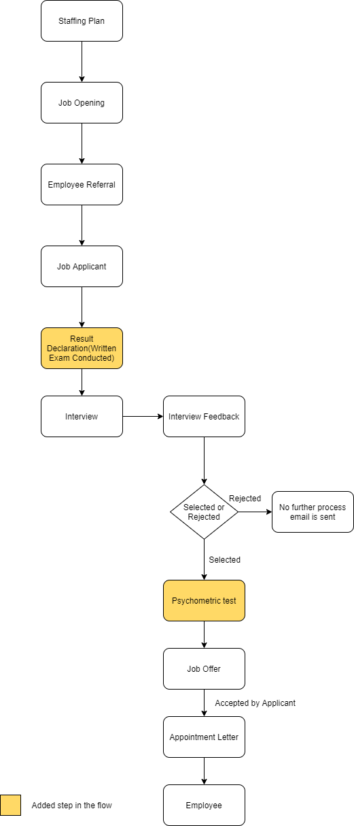

Fig:Required Recruitment Process

2.1Job Applicant:

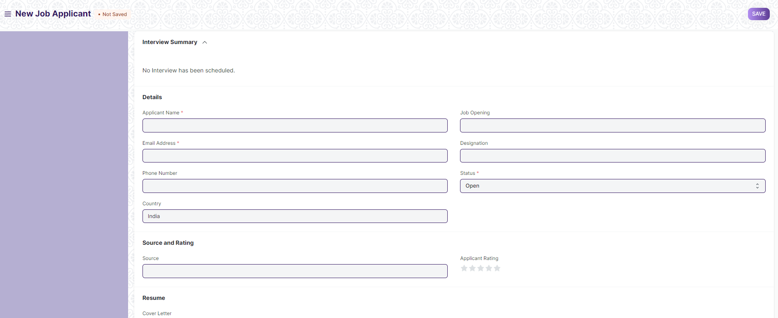

Business Requirement:
- There should be a “table” to maintain “Educational Qualification” with the fields like:
- Name of School/University
- Qualification
- Level(Graduate/Post Graduate and so on)
- Year of Passing
- Percentage
- Subjects(Major and Optional)

- There should be “Attach” field for uploading various required documents like 10th Marksheet,12th Marksheet and other required educational documents as well as other documents.

Remark: Mandatory fields will be discussed later.

2.2 Interview
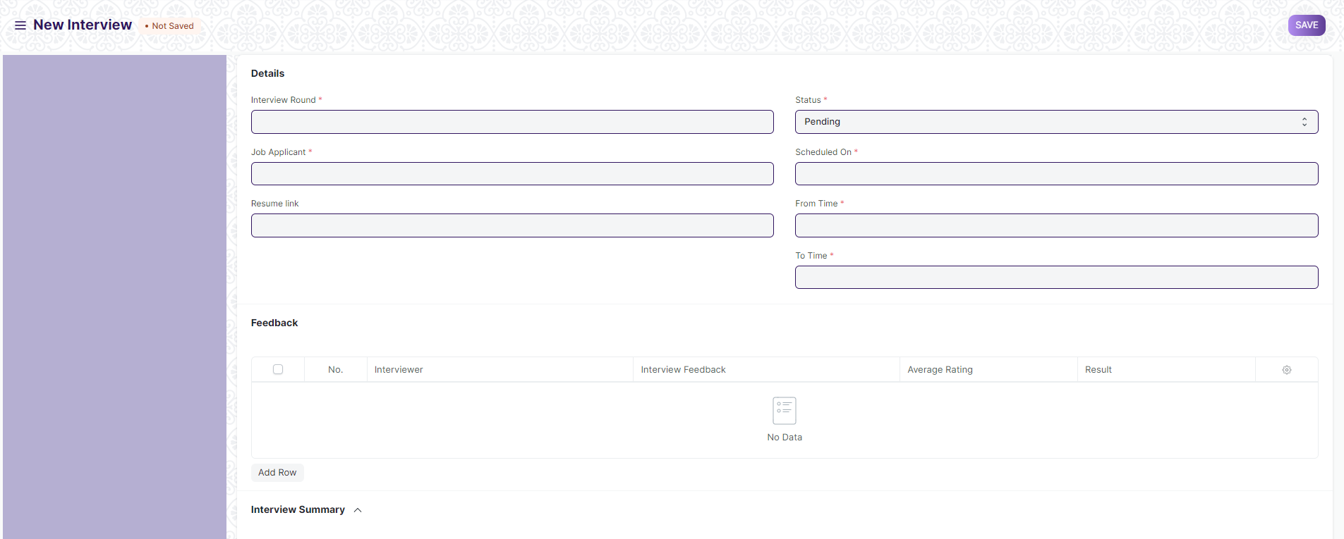
Business Requirement:
- In Interview Screen,in”Feedback table” the average rating field of the Feedback child table should be a numeric field rating from 0-5/0-10
3.Employee Lifecycle

3.1 Employee Promotion:

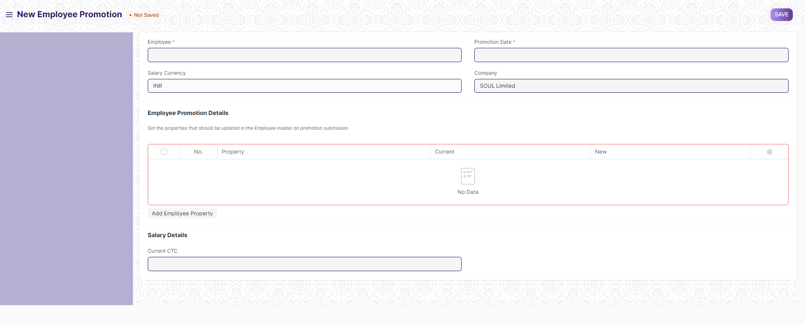

Business Requirement:
- There should be “Attach” field for uploading various required documents as a proof .
Remarks:Number of attached fields and labels will be discussed.

3.2 Employee Separation:

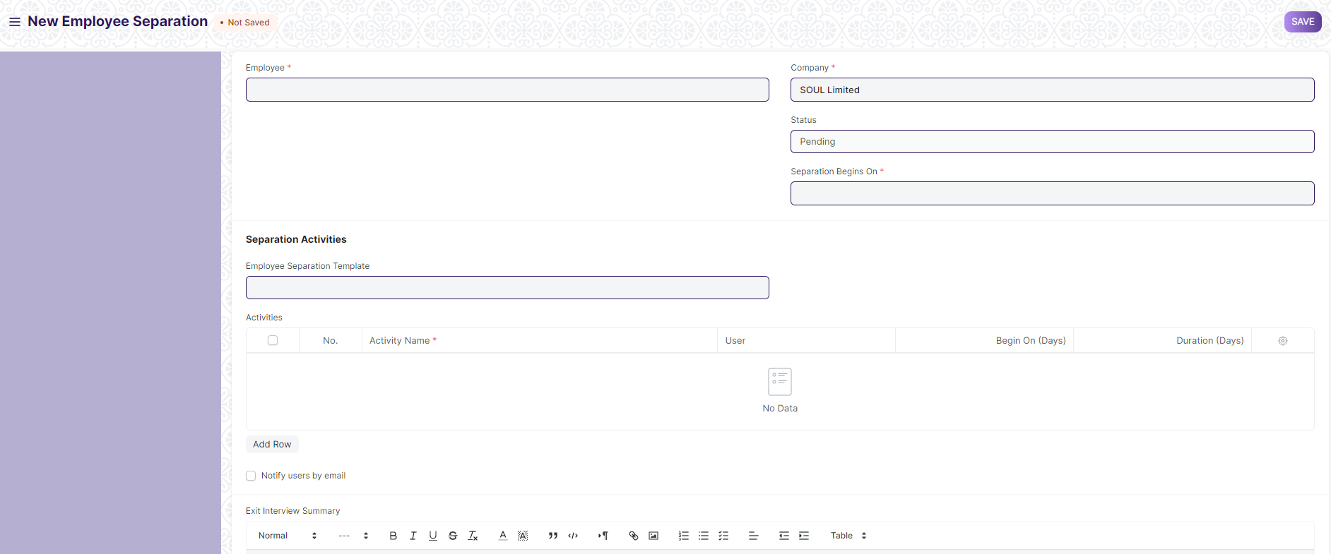

Business Requirement:
- There should be “Attach” field for uploading various required documents as a proof .
Remarks:Number of attached fields and labels will be discussed.

3.3 Employee Grievance:

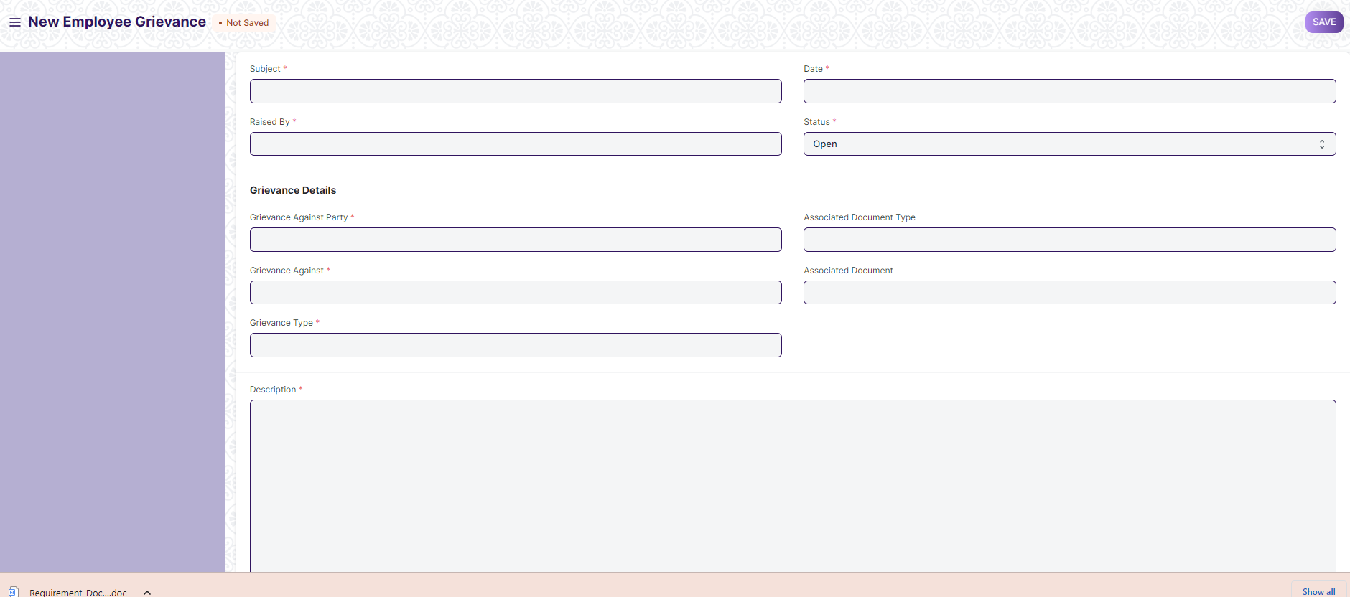

Business Requirement:
- There should be “Attach” field for uploading various required documents as a proof .
Remarks:Number of attached fields and labels will be discussed.

- There should be a “Workflow” for Employee Grievance and accordingly the authorities should be notified.
Remarks:In the existing application we do not have a workflow.Required workflow along with the concerned authorities need to be discussed.

- There should be a provision of “Acceptance of Resignation” in Employee Separation screen.
Remarks:In the existing application we do not have a workflow.Workflow to be developed in this way:
Once the resignation process is started , there should be a feature to manage the notice period , and the tentative final resignation date in the employee screen. The higher authority also be able to accept the final resignation before the final resignation date.

- There should be fields like:
- Notice Period Days
- Tentaive Final Resignation Date

